Emergency/Hotline Numbers  WV 2-1-1 data base of services available 24/7  Go to: www.WV211.org or  Text your zip code to 898-211 or Call 2-1-1  Human Trafficking Hotline  Phone: 1-888-373-7888  Text "BEFREE" or "HELP" to 233733  Anonymous Tip Line: 888-373-7888  www.humantraffickinghotline.org  Report missing children or child porn: 800-THE-LOST  Email: help@humantraffickinghotline.org  - Abuse &Neglect Hotline (child & adult) 800-352-6513  - National Domestic Violence Hotline 800-799-7233  - National Runaway Hotline 800-621-4000  - National Sexual Assault Hotline 800-656-4673  - National Suicide Prevention 800-273-TALK (8255)  - Poison Control Center 800-222-1222  - Gamblers Helpline 800-426-2537  Wetzel County Office of Emergency Services  304-455-6960  Code Red Emergency Notification System  https://public.coderedweb.com/CNE/183353CC9EC4  Radio: AM: 1170; 1330; 1610 FM: 103.9; 99.5  Television: channels 7, 9, & 12  Ambulance●Fire●Law Enforcement  9-1-1  WV State Police 800-982-9877
  This directory is for informational purposes only. The information provided is believed to be accurate at the time of printing. Entries in this directory are not endorsed by the organization.
  Any exclusions are purely accidental and do not reflect disapproval. This guide may be copied for personal use but should not be modified and reproduced.
  Contact 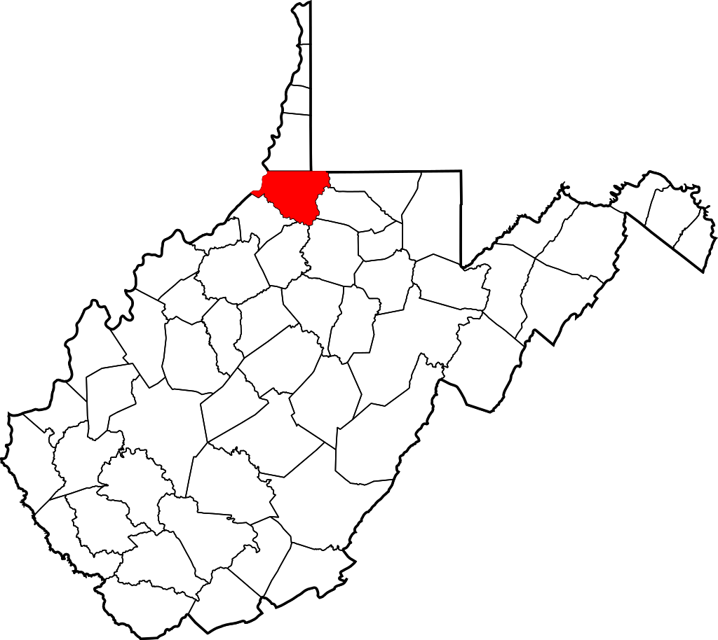
  Elizabeth Seckman,
  Wetzel County Family Resource Network Coordinator
  Phone: 304-455-2468
  Email: eseckman@wcccfwv.org
  Web: www.wcfrn.blogspot.com
  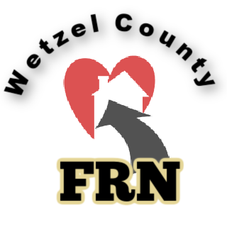 |  | Wetzel County Resource List  128 Main Street  New Martinsville, WV 26155
  
  Wetzel County Resource List
    - A full, digital guide is available at www.wcfrn.blogspot.com
WV Dept. of Health and Human Resources  Wetzel Office: 304-455-0920  Client Services Hotline 800-325-6513  Children & Family Service  Birth to Three 304-455-0920  WIC 304-337-2011  Parents as Teachers 304-455-2468  WCCCFWV Hundred 304-775-2000  Healthy Grandfamilies 304-455-2468  CASA 304-233-0333  The Lighthouse 304-398-2311  Change, Inc. 304-845-7726  Gabriel Project 304-815-2956  Genesis Mobile Crisis Unit 866-897-8959  Little Lambs 304-455-1422  Little Red School House 304-455-1627  Headstart 304-337-2758  Children’s Programs/Services  Youth Services Systems 304-232-3441  WVU Extension Services (4-H) 304-455-0934  Foster Care  Genesis Foster Care 304-200-3374  Necco Foster Care 681-404-3777  Children’s Home Society 304-810-2460  BluePrints Foster Care 304-422-3159  / |  |  | Disability Services  Olmstead Coordinator 304-558-3287  Easterseals NM Clinic/Dr. Kitts 304-242-1390  Council on Independent Living 304-843-2306  The Seeing Hand 304-232-4810  WV Division of Rehabilitation 800-642-8207  Linx Residential & Respite Care 304-455-2757  REM/Mentor Group 304-337-9230  Northwood 304-455-3622  WVATS WV Assistive Tech 304-293-4692  Economic Services  Community Resources 304-455-0120  Catholic Charities 304-455-9740  Appalachian Outreach 304-830-5197  USDA Rural Development 304-242-0567  Housing & Urban Development 202-708-1112  FMHA 304-363-0860  Employment Services/Education  Senior Employment Program 304-218-2873  American Job Center 866-9JOB NOW  Jobs & Hope 304-962-7355  WorkForce WV 800-252-5627  Job Corps 800-733-JOBS  Wetzel-Tyler Adult Ed. 304-398-4924  WV Northern Community College 304-455-4684  Legal Aid of WV 866-255-4370 |  |  | Mental Health/ Substance Abuse  Behavioral Health  Fox Run 740-695-2131  Northwood 304-455-3622  Wellspring 304-455-3035  Break Thru Detox Center 304-221-4528  New Beginnings MAT Center 304-398-2298  St. Joseph’s Mobile MAT Unit 304-481-4829  YSS Prevention Services 304-217-3871  TakeAction Recovery & Resource Center 304-217-3871  Senior Services  Senior Protection Hotline 304-558-1155  Wetzel Senior Com. on Aging 304-455-3220  Medicare Call Center 877-987-4463  Social Security Administration 304-232-7710  Veteran’s Services  Veteran’s Crisis Line 800-273-8255  Clarksburg VA Medical Center 304-623-3461  Belmont County VA Clinic 740-986-4326  Division of Veteran’s Affairs 304-238-1085  Helping Heroes 304-232-0114  Sexual Assault/ Human Trafficking  SAHC (Sexual Assault Help Center)  304-234-1783  Women’s Services  Wetzel County YWCA 304-455-6400

